Case Study

The SNFCC ferrocement Canopy construction and erection

1. Introduction

The ferrocement canopy if the opera building is made out of two ferrocement skins: the superior one (top skin) and the interior one (bottom skin). They are connected together by ferrocement diaphragms and steel diagonal circular hollow tube sections. Each skin consists of different ferrocement panels concerning their geometry, casted into steel formworks during the canopy preconstruction phase. The general methodology, for the canopy, envisaged foresees the preconstruction on the ground of 6875x3173mm (typical prefabricated panel dimension) precast elements corresponding to parts of the bottom and top skin of the canopy that will be connected with splice zones at the final canopy position which have equal dimensions of 577mm between the ribs.

1. Preconstruction

Each ferrocement panel is casted on metal formwork (4000x800) installed on metal benches. It consists of a thick steel plate (t=10mm), that is made rigid with upn sections, is leveled and is connected via stiffeners to turnbuckles which allow the creation of the exact curvature for each panel. The steel plate is controlled by 64 points that correspond to the panels geometry. Deformations and deflection on the surface at the plate have been examined using high accuracy leveler and invar rod. The collected data was processed via GLM (3d observer) in order to examine the flatness. (photo)

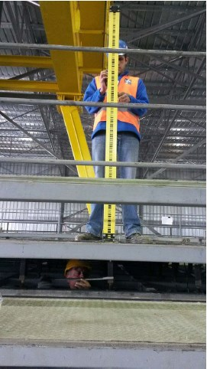

Subsequent to the surface adjustment, the panel’s reinforcement was placed on the casting mould. The reinforcement was placed on the mould in a way that is constructed ribs and beams axes to perfectly match the theoretical axes that had been set out to the casting table. Correction movements were performed in order to eliminate deviations, by investigating the position of the implemented to the reinforced couplers. (photo) 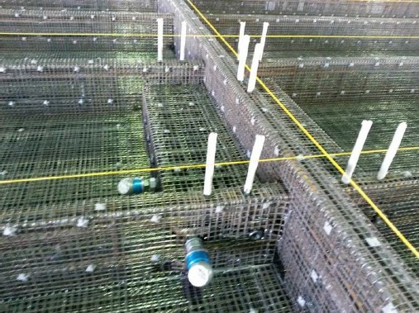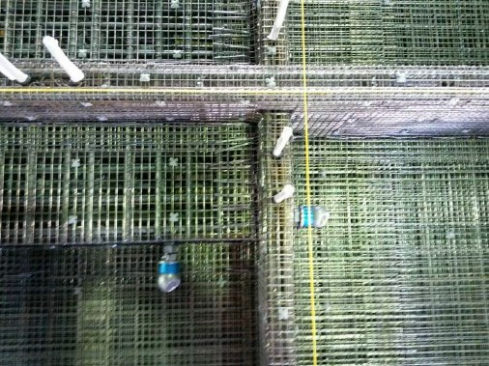

Reflective targets mounted on steel plates, placed on side moulds were used in order to verify the alignment on ribs and beams. (photo)

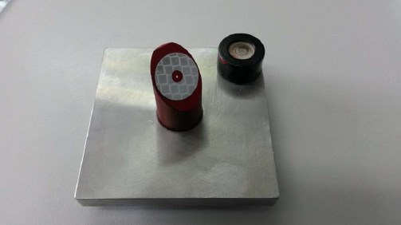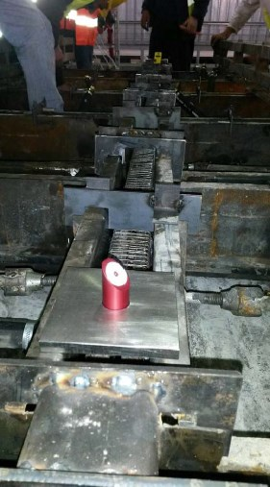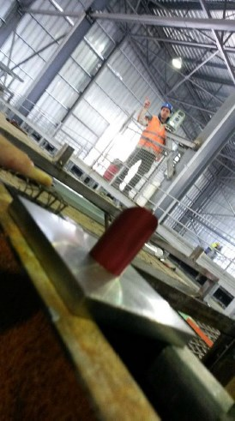

Finally control points were installed on the inner side of the panel, in order to be used during the erection sequence via the transformation from Local(preconstruction) to Global (erection) reference system. (photo)



1. Geometry Verification Prior to erection

For each unit a fully reference registry report was created by using 3D Laser Scanning Techniques. Each panel was verified at its geometry:

* Curvature of the casted slab
* Slab thickness
* ER points coordinates deviation in relation to As-Built values
* Ribs and Beams width, thickenings and axis (photo)



As built data was collected referring to the couplers and anchors implemented on casted unit and reports were created. (photo)

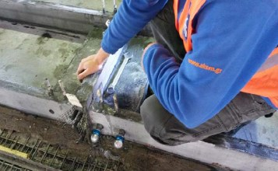

1. Canopy Erection
2. Network establishment

For all the surveying works during the canopy’s erection, a high accuracy network was installed on the Opera building’s roof that were be incorporated to the Global Coordinate System. The numbers of total reference points were installed were mainly determined by the density of the scaffoldings, which is actually the main obstacle between the station and the reference points.

1. Panels installation on scaffolding

For the panel installation on the scaffolding the adjustments were being performed by the use of direct measurements to the 12 control points installed on the bottom of the casted unit with the use of high reflective targets, either to the 6 control points installed on the inner side of the panel with the use of flanges.

1. Steel structure erection
2. Upper skin installation

For the upper skin panels installation followed the same procedure as the bottom skin panels installation. The adjustments were being performed by the use of direct measurements to the 12 control points installed on the bottom of the casted unit with the use of high reflective targets.